Q.1.Draw a labeled diagram of a desktop PC, clearly marking the motherboard, CPU, RAM, GPU, and both HDD and SSD storage components.
ANS- 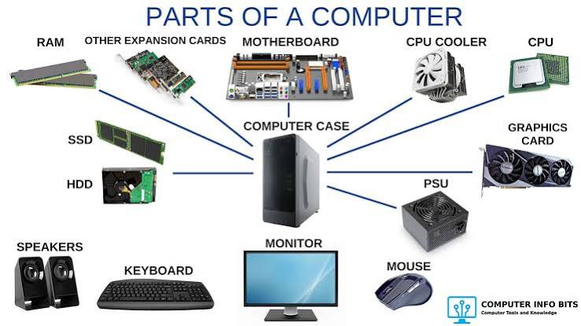

Q.2.Create a comparison table showing the main differences between HDD and SSD storage in terms of speed, durability, and typical use cases.<br><br><em><strong>Hint:</strong> Think about which one is faster, which is more shock-resistant, and where you would usually find each type (laptop, gaming PC, etc.).</em>.
ANS-
Feature | HDD | SSD
Heat Generation | Generate more heat | Generate less heat
speed | Slower (80-160 mb/s) | Faster (500-7000 mb/s)
Weight | Heavy | Lighter and more compact
Durability | Less durable because it has moving parts | Durable because it has no moving parts
Storage capacity | It has more capacities( up to 20TB+) | It has low capacities ( 128GB to 8TB)
Cost | Cheap | Expensive

Q.3.Write a short explanation (2-3 sentences each) describing the role of the CPU, RAM, and GPU in running a game like PUBG or Free Fire on a PC.

ANS- 1. CPU- It process the game instruction or run the game with the help algorithms and make the game run smoothly .
2. RAM- It temporarily stores the game data while you are playing . It helps games load faster
3. GPU- It based for high performance tasking like a heavy game or multi-tasking or keep cools the CPU with the help of fan.

Q.4.Imagine you want to upgrade your PC to run the latest version of FIFA smoothly. List which hardware components you would consider upgrading and explain why for each.
ANS- In my opinion the components are replacing is (processor or GPU) because they are compatible for the gaming because (CPU are run all commands or tasking smoothly) (GPU are perform task with the help of CPU or cool the CPU so all work together) .
: Latest version of CPU is a (intel- i5,i7,i9.)
:Latest version of GPU is a (RTX- 5080,5090)

